**MIT School of Engineering**

**Department of Computer Science and Engineering**

**Project Synopsis**

**Group ID: 22**

**Project Title: Controlling Computer using Hand Gestures**

**Group Members:**

|  |  |  |  |  |
| --- | --- | --- | --- | --- |
| **Enrollment Number** | **Roll No.** | **Name of student** | **Email Id** | **Contact Number** |
| MITU18BTCS0121 | 2183149 | Pradnya Kedari | pradnyark22@gmail.com | 9112179831 |
| MITU18BTCS0102 | 2183214 | Shubhangi Kadam | shubhangijkadam0524@gmail.com | 8669098264 |
| MITU18BTCS0045 | 2183181 | Rutika Chaudhari | rutika2900@gmail.com | 7972593750 |

**Problem Statement:** Controlling Computer using Hand Gestures.

In this project we will develop a project with Python, Deep learning and Computer vision technology.

**Abstract**:

The presence on market of the low-cost webcams with, at least, satisfactory qualities open up new directions regarding the implementation of human computer interaction (HCI) interfaces. Gesture is one of the most vivid and dramatic way of communications between human and computer. Hence, there has been a growing interest to create easy-to-use interfaces by directly utilizing the natural communication and management skills of humans.

In this project, we decided to design a real-time human-computer interaction system based on hand gesture. Specifically, we will use the convolutional neural network (CNN) in complete process. This application presents a hand gesture interface for controlling a computer that is performing different operations using neural network. The proposed system recognizes a set of specific hand gestures. Our application is based on five phases, Image frame acquisition, Hand tracking, Features extraction, Recognition of gestures and Classification (perform desired operation). A frame from the webcam camera is captured, and then hand detection, hand shape features extraction, and hand gesture recognition will be done.

In this project, we developed a generic Deep Neural Network-Based model for controlling a computer using hand gestures recognition. We will build a system to handle a device using hand gestures.

Our objective is to build a suitable dataset, to build and train a model for feature extraction and classification of hand gestures, to use a trained model for classification of hand gestures and recognizing an action and perform an operation accordingly, and to control a computer and perform related activities using hand gestures with the help of computer vision and deep learning algorithm.

**Literature Survey:**

In computer science and language technology, gesture recognition is an important topic which interpret human gesture through computer vision algorithms. There are various bodily motion which can originate gesture but the common form of gesture origination comes from the face and hands. The entire procedure of tracking gesture to their representation and converting them to some purposeful command is known as gesture recognition. Various technologies has been used for the design and implementation of such kind of application.

The first way of interaction with computer using hand gesture was first proposed by Myron W. Krueger in 1970 [1]. The aim of the application was reached and the mouse cursor control was achieved using an external webcam (Genius FaceCam 320), a software that could interpret some hand gestures and then turned the recognized gestures into operating system commands that controlled the mouse actions on the computer display screen [2]. Adopting hand gesture as an interface in HCI will allow the deployment of a wide range of applications without any physical contact with the computing environments [3]. Nowadays, majority of the HCI is based on mechanical devices such as keyboard, mouse, joystick or game-pad, but a growing interest in a class of methods based on computational vision has been emerged due to ability to recognize human gestures in a natural way [4].

The main purpose of gesture recognition is to identify a particular human gesture and convey information to the computer. Overall aim is to make the computer understand human gestures, to control remotely through hand postures a wide variety of devices [5]. The automatic vision-based recognition of hand gesture for sign language and for control of electronic devices, like digital TV, play stations was consider as a hot research topic recently. But the general problems of these works rise due to many issues, such as the complex backgrounds, the skin color and the nature of static and dynamic hand gestures. Hand gestures recognition for television control is proposed by [6]. In this system, only one gesture is used to control television by moving user hand. On the display, a hand icon appears which follows the user's hand.In this paper [7], a real-time gesture-based HCI system who recognizes gestures only using one monocular camera and extend the system to the HRI case has been developed. The developed system relies on a CNN classifier to learn features and to recognize gestures.

The Hidden Markov Model serves as an essential tool for the recognition of dynamic gestures in real time. The system makes use of the Hidden Markov Model (HMM), works in real time and is designed to work in static backgrounds. The system makes use of LRB topology of HMM in conjunction with the Baum Welch Algorithm for training and the Forward and Viterbi Algorithms for testing and evaluating the input observation sequences and generating the best possible state sequence for pattern recognition [8]. In this paper [9], the system is implemented although seems to be user friendly as compared to modern device or command based system but it is less robust in detection and recognition. Need to improve the system and try to build more robust algorithm for both recognition and detection even in the cluttered background and a normal lighting condition. Also need to extend the system for some more class of gestures as system is implemented for only 6 classes. However this system can use to control applications like power point presentation, games, media player, windows picture manager etc. In this paper [10], hand gesture laptop uses an Arduino Uno, Ultrasonic sensors and a laptop to carry out the operation of controlling media playback and volume. Arduino, ultrasonic sensors. Python used for serial connection. This type of technology can be used in classroom for easier and interactive learning, immersive gaming, interacting with virtual objects on screen.

Arduino UNO and ultrasonic sensors based hand gesture to control a computer where they can play pause videos and scroll up and down pages [11]. This paper [12] suggest an efficient ultrasonic based hand gesture monitoring system which is designed with the help of Arduino microcontroller ATMEGA32. The hand gestures recognized effectively with ultrasonic sensors. It is proved that no additional hardware is required to detect hand gestures and proved that simple inexpensive ultrasonic sensors can be used to find different ranges to recognize hand gestures. In this paper [13], Arduino UNO ARDUINO and python programming with wired ultrasonic sensor based hand gesture system to control a computer where they can zoom in/out and rotate the image is developed. This is successful trial of working of hand motion sensing system using sensors i.e. ultrasonic sensors and finger contact sensors and using in it to Arduino kits in wireless mode using radio frequency. HCI for MS office and media player and have their own dataset, used skin coloured based technique [14]. Application that switch in a Web browser, Web page scrolling, Task switching, Changing the slides of the presentation, Play/pause the video, Video forward and rewind is implemented. Arduino, PySerial, PyautoGUI, etc. used [15].

**Proposed System (Block Diagram):**

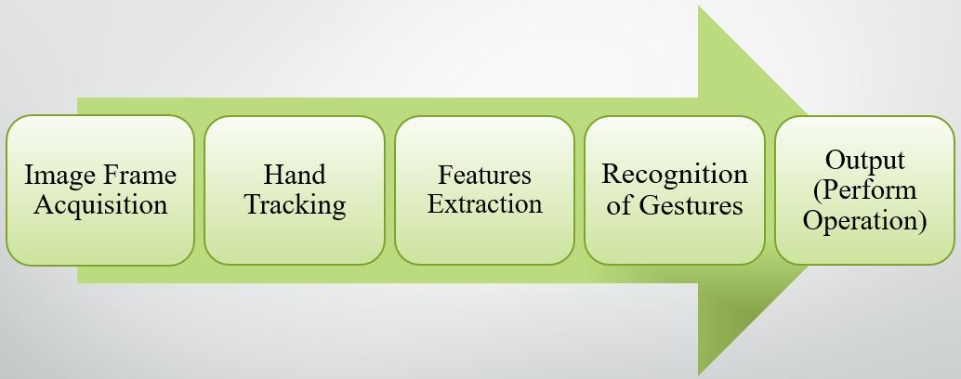

**Fig. 1 Block diagram of methodology of proposed system**

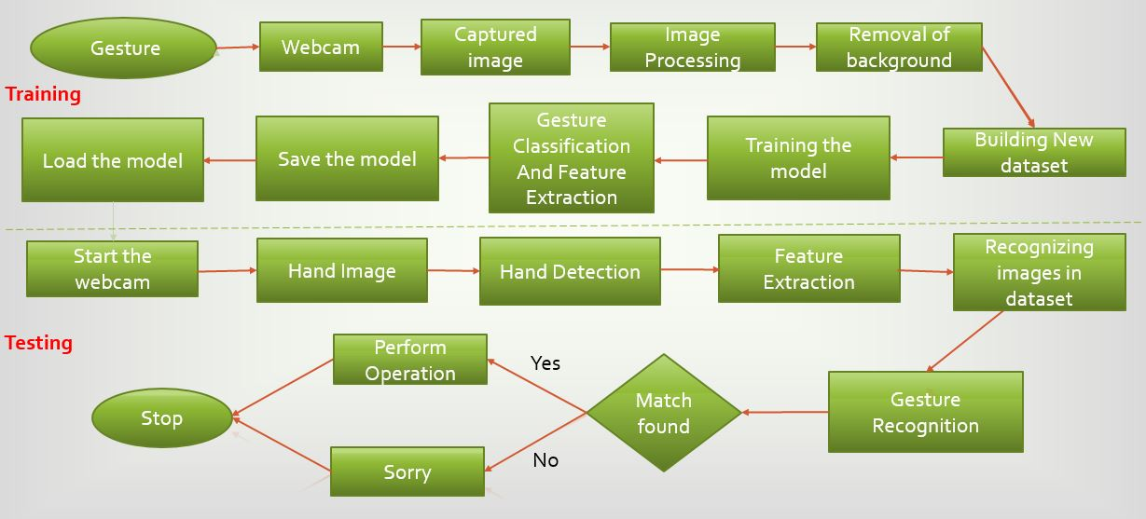

**Fig. 2 Block diagram for proposed system**

**Conclusion:**

With the development of today’s technology, and as humans tend to naturally use hand gestures in their communication process to clarify their intentions, hand gesture recognition is considered to be an important part of Human Computer Interaction (HCI), which gives computers the ability of capturing and interpreting hand gestures, and executing commands afterwards.

Research into hand gestures has become an exciting and relevant field; it offers a means of natural interaction. Conventional interactive methods depend on different devices such as a mouse, keyboard, and touch screen, joystick for gaming and consoles for machine controls.

In this application, we will develop a deep learning model for controlling a computer using hand gestures with the help of Python, Keras, Tensorflow and OpenCV. We can define a project as creating a dataset, training a model and testing this model in real time.

Some popular applications of hand gestures includes sign language recognition, home automation, clinical and health, virtual environment, robotic control, PC and tablet app, gaming, etc.

Thus, we have defined a problem statement and also decided the methodology, dataset, technologies and algorithm to be used. Also various research and survey regarding the application is done.

**References:**

1. M. KRUEGER, Artificial reality II, Addison-Wesley Reading (Ma), 1991.

# Horatiu-Stefan Grif and Cornel Cristian Farcas, "Mouse Cursor Control System Based on Hand Gesture", 9th International Conference Interdisciplinarity in Engineering, INTER-ENG 2015, 8-9 October 2015, Tirgu Mures, Romania.

1. H.A JALAB, "Static hand Gesture recognition for human computer interaction", Asian Network for Scientific Information technology journal, pp. 1-7, 2012.
2. J C.MANRESA, R VARONA, R. MAS and F. PERALES, "Hand tracking and gesture recognition for human-computer interaction", Electronic letters on computer vision and image analysis, vol. 5, pp. 96-104, 2005.
3. H. HASAN and S. ABDUL-KAREEM, "Static hand gesture recognition using neural networks", Artificial Intelligence Review, vol. 41, pp. 147-181, 2014.
4. W. FREEMAN and C. WEISSMAN, "Television control by hand gestures", Proc. of Intl. Workshop on Automatic Face and Gesture Recognition 1995, pp. 179-183, 1995.
5. Pei Xu, "A Real-time Hand Gesture Recognition and Human-Computer Interaction System", arXiv:1704.07296v1 [cs.CV] 24 Apr 2017.
6. J.R Pansare, Malvika Bansal, Shivin Saxena, Devendra Desale, "Gestuelle: A System to Recognize Dynamic Hand Gestures using Hidden Markov Model to Control Windows Applications", International Journal of Computer Applications (0975 – 8887) Volume 62– No.17, January 2013.
7. Ram Pratap Sharma and Gyanendra K. Verma, "Human Computer Interaction using Hand Gesture", Eleventh International Multi-Conference on Information Processing-2015 (IMCIP-2015).
8. Rohit Mukherjee, Pradeep Swethen, Ruman Pasha, Sachin Singh Rawat, “Hand Gestured Controlled laptop using Arduino”, International Journal of Management, Technology And Engineering, October 2018.
9. Ayushi Bhawal, Debaparna Dasgupta, Arka Ghosh, Koyena Mitra, Surajit Basak, “Arduino Based Hand Gesture Control of Computer”, IJESC, Volume 10, Issue No.6, June 2020.
10. Udit Kumar, Sanjana Kintali, Kolla Sai Latha, Asraf Ali, N. Suresh Kumar, “Hand Gesture Controlled Laptop Using Arduino”, April 2020.
11. Sarita K., Gavale Yogesh, S. Jadhav, “HAND GESTURE DETECTION USING ARDUINO AND PYTHON FOR SCREEN CONTROL”, International Journal of Engineering Applied Sciences and Technology, 2020, Vol. 5, Issue 3, ISSN No. 2455-2143, July 2020.
12. Ram Pratap sharma, Gyanendra Varma, “Human computer interaction using hand gesture”, 2015.
13. J. S. Vimali, Senduru Srinivasulu, J. Jabez, S. Gowr, “Hand Gesture Recognition Control for Computers Using Arduino”, 2020.

**Annexure:**

**Annexure I: Form A-Title Approval (for offline mode)**

**Annexure II: Form B-Market and financial feasibility (verify from guide)**

**Annexure III: Literature survey paper or links**